SHORT DESCRIPTION

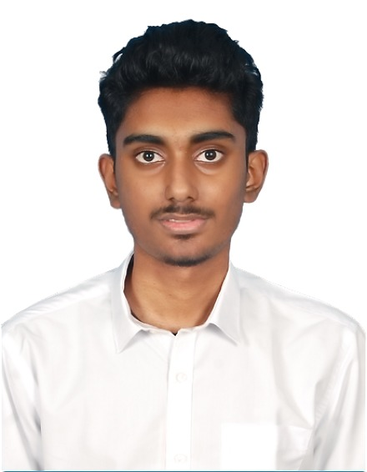

**Selva Karthik S** is currently a third-year undergraduate student pursuing Computer Science and Engineering at SASTRA Deemed University, Thanjavur. His areas of interest include Machine Learning, Deep Learning, Natural Language Processing, and Image Processing. He is passionate about leveraging advanced computational techniques to solve real-world problems.

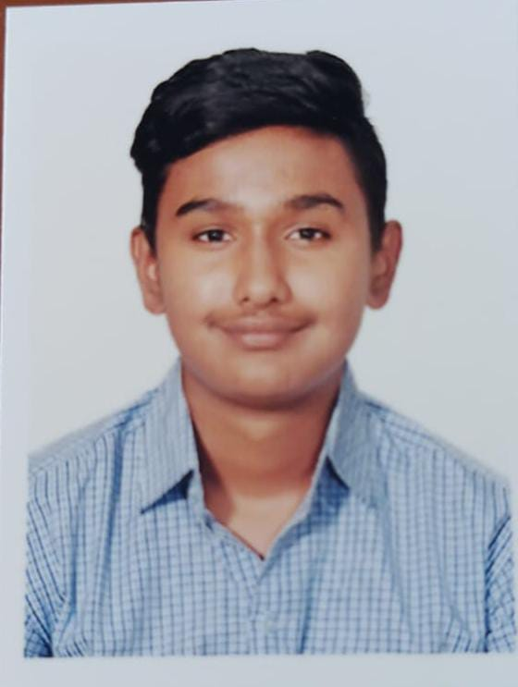

**Achuthan V** is a third-year undergraduate student specializing in Cyber-Security within the Computer Science and Engineering program at SASTRA Deemed University, Thanjavur. His areas of interest span Machine Learning, Deep Learning, and Cyber-Security. He is dedicated to integrating cutting-edge technologies into secure and intelligent systems.